

Motorola A1600

Description
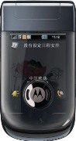
This bugger will sport quad-band GSM connectivity, a 3.2-megapixel camera (with autofocus), WiFi, assisted-GPS, a couple of built-in games, a "talking dictionary" and a Linux-based OS

STORE PRICE: Rs 14,231 /-
ONLINE PRICE: Rs 13,942 /-

Brand : Motorola
Model Name : A1600
Released Year : 2008
Phone Memory : 27 MB user available memory
External Memory : microSD (TransFlash), up to 4GB
Colors : Black
Form : Flip
Dimensions : 98.9 x 53.5 x 19.6 mm
Weight : 128 g

